TC-AUTH-024
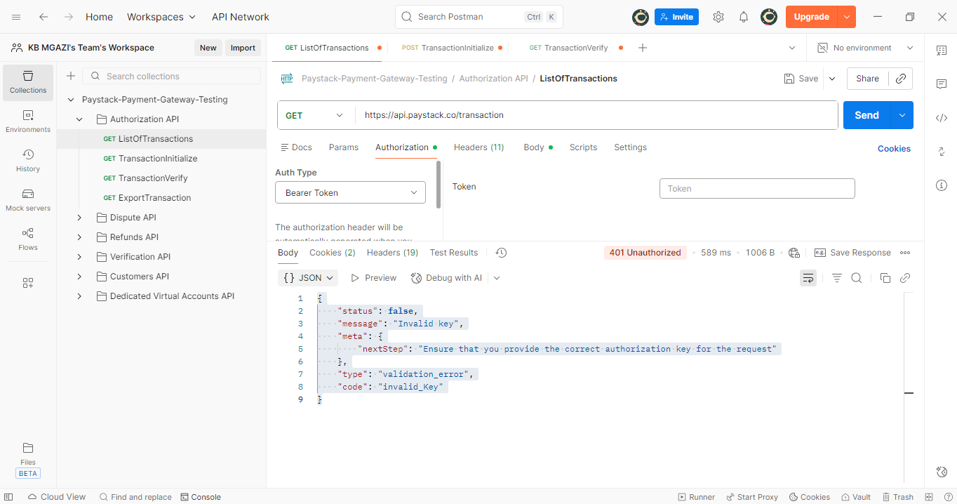
Response:
{
"status": false,
"message": "Invalid key",
"meta": {
"nextStep": "Ensure that you provide the correct authorization key for the request"
},
"type": "validation_error",
"code": "invalid_Key"
}

